Zion News

11609 Frankstown Rd

Pittsburgh, PA 15235

412-242-2626 **April, 2025**

www.zionpennhills.org

https://www.facebook.com/zionpennhills/

***The church in the heart of Penn Hills that is the heart of Penn Hills***



**“The Everything of Nothing”**

The sun is rising; the dawning of the third day after Jesus of Nazareth had been crucified. His disciples were in hiding for fear they might be incriminated as accomplices of their slain leader. They were hiding behind closed doors in fear and grief.

The women, friends of Jesus, arise early in the morning, the day after the Jewish Sabbath. They had a sad, solemn duty to perform. As light was welcoming the dawn of a new day, they came to anoint the body of their beloved Master with spices. They fully expected to find Jesus’ body. They wondered, “Who will roll away the heavy stone that seals the entrance to the grave?” What they expected was not to be.

What did they find? Nothing! Where is he? Where is the body? What have they done to him? Haven’t they done enough by torturing and killing him? Now nothing! Nothing!

Then came the shortest and best Easter sermon ever preached, “The angel said to the women, ‘Do not be afraid; for I know that you seek Jesus who was crucified. He is not here; for he has risen, as he said. Come and see the place where he lay. Then go quickly and tell his disciples that he has risen from the dead, and behold, he is going before you to Galilee; there you will see him. Lo, I have told you.’”

The grave held nothing because death held no control over the life giving power of God. Our God, who created all, has the ultimate power to recreate all. Let us rejoice in the great good news of “nothing” on the first Easter and the everything of God with us now. Out of our seeming emptiness comes our everything, our everything in Christ through the eternal love of God who fills our nothing with new life, now and forever.

CHRIST IS RISEN! HE IS RISEN INDEED! And so will we!

In Christ,

Pastor Neumann



**Easter Egg Hunt Donations:** On Sunday, April 20th, we will have an Easter Egg Hunt here at Zion after worship. If you would like to donate any individually wrapped candy, or small trinkets, there will be a basket in the Gathering Space. If you would like to make a cash donation, please see contact Debbie Rall or Tammy Belohlavek. **The deadline for donations will be Palm Sunday, April 13th**. Thank you in advance!

Thank you to all who helped to prepare for and serve at the Food Pantry in March! We ended up serving over 142 households.

Our next pantry meets on **Saturday, April 12th.** Therefore,and if you are able to help, with set-up on Friday, April 11th from 9am-12pm in the Community Room or during the pantry on the 12th from 8:30am-12:00pm, that would be most appreciated!

Thank you again for all of your time, efforts, prayers and support towards making a difference in our local community and beyond!

Our collection of health and beauty items is looking good, but we could use a little more of some certain items. When shopping, please consider buying deodorant, shampoo, toothpaste and/or soap. As always, you can put the items in the bin by the coat rack. Those who come to Zion’s Food Pantry really do appreciate these items. Thank you so much

**Food Pantry News:**  Zion's Food Pantry Leadership received news this week of an Ethel Verney grant award of $12,000 for the coming year. The news came from the chair of the synod's Mission Endowment Fund Board. This grant, along with donations from the Zion congregation and others, will enable us to continue to purchase food from the Pittsburgh Food Bank and distribute those food items to our neighbors in need.

Thanks be to God for Ethel Verney's life, witness and stewardship! Her generous bequeath to the SWPA synod has enabled grants in her name to congregations and ministries throughout the synod, with the provision that the funds provide relief and support for people living in poverty in the area the synod serves.

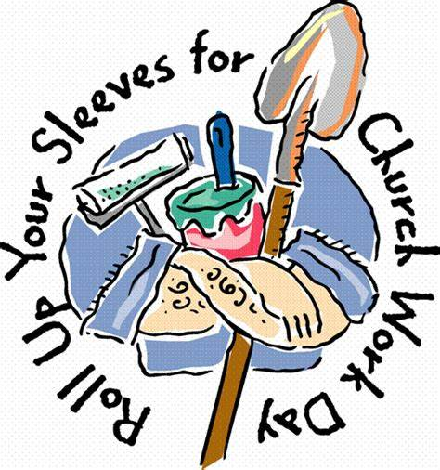

**Property Work Day:** Zion members and friends, please, please join us for a work day on **Saturday, May 3rd** from 9-12 rain or shine. There is plenty to do, inside and out. If you can hold a paintbrush, screwdriver, or pull a weed, we need you. Some light work and some moderate work. Refreshments will be provided.



**Newsletter Deadline:** Do you have an idea for an article, update on a project, or a photo from a Zion event or a shout-out or thank you? We would love to have it! All articles are due by the 20th of each month. Please send them via e-mail to: [julie@zionpennhills.org](mailto:julie@zionpennhills.org).

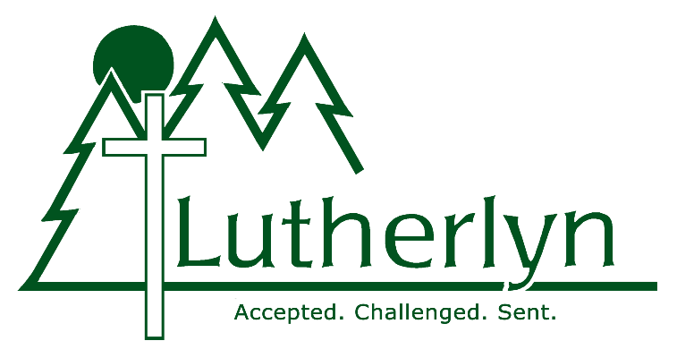

**Lutherlyn Summer Camp:** Registration has begun! If you are interested in attending summer camp at Lutherlyn during any of the weeks listed on the flyer posted on the kiosk beginning June 15th, please reach out to Debbie Rall. Zion will pay a portion of the cost. Any questions, please see Debbie Rall.



**Zion Book Club selections for 2025:**

Apr. 21 *Orbital* Samantha Harvey Chris D

May 19 *The Reading List* Sara Nisha Adama Jean B

Jun. 16 *Horse*  Geraldine Brooks Jean P

Jul. 21 *The Women* Kristin Hannah Elna S

Aug. 18 *Rust* Eliese Celeste Goldbach Sue B

Sep. 15 *Thursday Murder Club* Richard Osman Samara D

Oct. 20 *The Ride of Her Life* Elizabeth Letts Laura P

Nov. 17 *The First Ladies* Marie Benedict & Kathy K

Dec. 15 Book selection potluck

We meet at 1:00pm in the Gerhard Lounge. Everyone welcome!

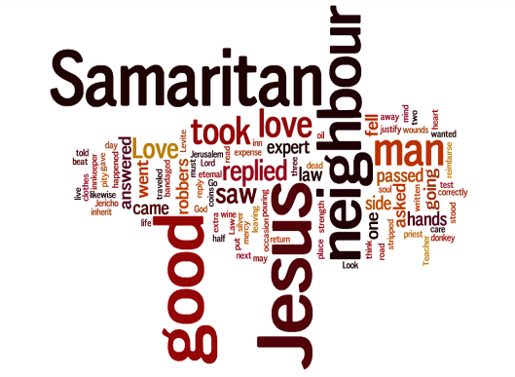

**Graham Standish Working Group Update:** The proposal for the future of Zion was presented to the Zion council at their meeting in February. The council will take the month of March to discern this proposal and will then vote on it at their March meeting. Pending the council vote in March, informational sessions will be scheduled with the congregation after that. Please continue to keep this group and its work in your prayers.

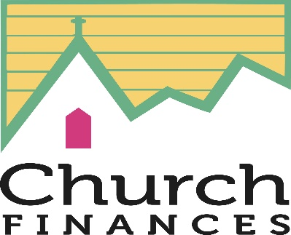

**Zion Lutheran Church Budgeted Finances as of February 28:**

Offering Income: $ 28,919.52

Other Income:* $ 11,873.00

Total Income: $ 40,792.52

Total Expense: $ 58,823.69

Net: $(18,031.17)

*Thomas Child Care and Learning Center, AIU, Apartment, and other groups who use our facilities



**April 13: Palm Sunday Worship**

In-person worship at 9:30am

Live-stream over Facebook

Procession with Palms

**April 17: Maundy Thursday**

**Communion Worship**

In-person worship at 7:00pm

**April 18: Good Friday Tenebrae**

In-person worship at 7:00pm

**April 20: Easter Sunday**

**The Resurrection of Our Lord**

In-person worship at 9:30am

Live-stream over Facebook

Afterwards: Easter Egg Hunt for children

**Come and celebrate the great good news that**

**CHRIST IS RISEN! HE IS RISEN INDEED!**



We will celebrate monthly birthdays on the following Sundays:

Sunday, August 3

Sunday, April 6 Sunday, September 7

Sunday, May 4 Sunday, October 5

Sunday, June 1 Sunday, November 2

Sunday, July 6 Sunday, December 7

The remainder of the Sundays in a given month will be covered by council members. As always, we’re grateful for those who participate by bringing both sweet & savory goodies to share. If you would like to bring something, simply just add your name to the calendar in the Gathering Space. Any and all snacks & treats are welcome, and it helps the Parish Life folks know what we need from one week to the next! Should you have any questions, please feel free to reach out.

Respectfully – Parish Life Committee

 

Easter Lily, Tulip *(please circle one*), or Guest Musicians Fund.

The cost is $11.00 for each plant. You can make your donation

in any amount towards the Guest Musician Fund. Please fill out

the form below and place it in an envelope **with a check** made

out to **Zion Lutheran Church** and circle which fund you would

like below and place it in the offering plate or mail it to the

church. **Deadline to order either a Lily or Tulip is April 13th.**

**(please circle one)**

**Easter Lily**

**Tulip**

**Guest Musicians Fund**

**IN MEMORY OF__________________________**

**IN HONOR OF_____________________________**

**BY________________________________________**

## Prayer Requests

## Annette Felmley has 19 dental students that want to go on the Christian mission trip to Honduras In April. Please pray for 1 or 2 other Christian dentists to come along to help mentor students.

## Please pray for Tom Felmley and his team as they travel to India in May to help with a refugee crisis.

**Offering Count Schedule**

|  |  |  |  |
| --- | --- | --- | --- |
|  |  |  |  |
| April 6, 2025 | 10:45am | **Tony Lamorte** | **Laura Patchen** |
| April 13, 2025 | 10:45am | **Sue Clydesdale** | **Cindy Pierce** |
| April 20, 2025 | 10:45am | **Mary Lou D’Ambrosio** | **Jean Betker** |
| April 27, 2025 | 10:45am | **Sue Clydesdale** | **Chris Dippold** |
|  |  |  |  |
|  |  |  |  |



*We are concerned with maintaining a current Prayer List. If you see a name on this list that can be taken off or wish to add a name, please contact Julie in the church office. If you or someone you know (who is not on the prayer list) is in need of a pastoral visit, please call the church office and let them know. Thank you.*

**Rehab Facility:**

Evelyn Lamm (Concordia, Monroeville, Room 117)

Nancy Fabel (Rosebrook Living Facility, Sarver, PA, Room 116)

Paul and Mary Lou Feathers (Presbyterian Homes, Oakmont, Room 204)

**Memory Care Facility:**

Don Cook (Redstone Highlands in Murrysville, Room 46

**Prayers Requested for:**

Mary Lou D’Ambrosio Beth Rall

Amy Santoriello Denise Capobianco (friend of Sandra Short)

Elouise Brooky

Sandra Short

John Carter

Jenny Fabrizi

Marion Ertel

Wayne Stumpf

Ken Wagner

Barb Kelly (cousin of Bob Page)

Elaina Yoon (daughter-in-law of Kathy Gaberson

Sue Z. (friend of Annette Felmley)

Greg Felmley (brother of Tom)

John Mainarich (son-in-law of Pat Pope)

Shelly Clarke (friend of Kara Albrecht)

Carla Moio (cousin of Linda Mitnik)

Audri Erfort (cousin of Mary Lou D’Ambrosio)

Maggie Watson (daughter of Kathy Kraf)

Michael Gerdich (friend of Rhonda Pope)

Josh Cummings (nephew of Tony Lamorte

Patti Wunderley (sister of Linda Neumann)

Sandy Kovacs (sister of Linda Neumann)

David Uptagraffe (friend of Audri Erfort)

John Hayes (friend of Tom & Annette)

Richard Sabol (father of Andrew Sabol)

Gary Bunch (husband of Cheryl Bunch)

Mike Walsh (friend of Kathy Gaberson)

Katie Ritenour (cousin of Debbie Marks)

Sandy Hutchins (friend of Diane Santoriello)

Darnell Pope (brother of Sandra Short)

Steve Bell (brother of Rhonda Pope)

Chris Vuocolo(nephew of Mary Lou D’Ambrosio)



**APRIL BIRTHDAYS**

4/4 Nicholas Albrecht 4/15 Beth Rall

4/5 Tom Felmley 4/22 Elijah Raible

4/8 Robert Houghtelin 4/22 Diane Marburger

4/11 Curt Baumann 4/23 Avary Stover

4/13 Matthew Stiffler 4/29 John Carter

4/14 Ed Pope 4/30 George Dippold, Jr.



**APRIL ANNIVERSARRIES**

4/12/1980 Carol & Robert Dugan

4/20/2004 Caryn & Dan Price

4/25/1970 Diane & Rev. Randall Marburger



With thanksgiving to almighty God.  We rejoice at the birth of Jaxton Bennett Nieser born on March 26th at 6:17 pm.   Weighing 6lbs. 14oz.

Congratulations to Kaylee & Josh Nieser, parents and Julie Nieser and Tammy Belohlavek, grandparents.

**WE NEED MORE USHERS!**  If you are interested in helping to collect and present the offering, doing a head count for record keeping, dismiss rows for communion, please let Tony Lamorte

know at: [lamortet@verizon.net](mailto:lamortet@verizon.net). Thank you

Sunday, April 06, 2025  Mike Patchen  Ray Rall

Sunday, April 13, 2025  Tony Lamorte   Charlotte Fraser

Sunday, April 20, 2025  Mike Patchen  Ray Rall

Sunday, April 27, 2025  Tony Lamorte  Charlotte Fraser